1)What are weak learner?
2)What's the similarities and differences between Bagging, Boosting, Stacking?
3)What is a Gradient Boosted Decision Tree?
4)How GBDT works?
5)Why do we need GBDT?
6)Why do we need Gradient Boosted Decision Trees?
7)How can we improve Gradient Boosted Decision Trees?
8)What are the differences between GBDTs and Random Forests?
9)What are the advantages of GBDTs?
10)What are the disadvantages of GBDTs?

1)In ensemble learning theory, we call weak learners (or base models) models that can be used as building blocks for designing more complex models by combining several of them. Most of the time, these basics models perform not so well by themselves either because they have a high bias (low degree of freedom models, for example) or because they have too much variance to be robust (high degree of freedom models, for example).

2)All three are so-called "meta-algorithms": approaches to combine several machine learning techniques into one predictive model in order to decrease the variance (bagging), bias (boosting) or improving the predictive force (stacking alias ensemble).
- Bagging (stands for Bootstrap Aggregating) is a way to decrease the variance of your prediction by generating additional data for training from your original dataset using combinations with repetitions to produce multisets of the same cardinality/size as your original data. By increasing the size of your training set you can't improve the model predictive force, but just decrease the variance, narrowly tuning the prediction to expected outcome.
- Boosting is a two-step approach, where one first uses subsets of the original data to produce a series of averagely performing models and then "boosts" their performance by combining them together using a particular cost function (=majority vote). Unlike bagging, in the classical boosting the subset creation is not random and depends upon the performance of the previous models: every new subsets contains the elements that were (likely to be) misclassified by previous models.
- Stacking is a similar to boosting: you also apply several models to your original data. The difference here is, however, that you don't have just an empirical formula for your weight function, rather you introduce a meta-level and use another model/approach to estimate the input together with outputs of every model to estimate the weights or, in other words, to determine what models perform well and what badly given these input data.

3)A gradient boosted decision tree is yet another algorithm based on ensemble learning. However, it utilizes boosting (obviously) instead of its counterpart, bagging. Therefore, weak learners are converted to strong learners in a GBDT.
So, a GBDT is a decision tree based on the technique of producing an additive predictive model by combining decision trees that, of course, are weak predictors on their own. Therefore, GBDTs can be used for classifying or regressing, depending on the type of problem.
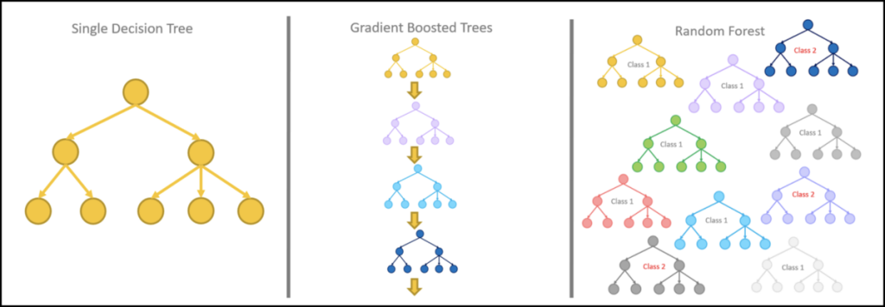

4)Classification
- Initial Prediction
- Calculate Residuals
- Predict residuals by building a decision tree
- Obtain new probability
- Obtain new residuals
- Repeat steps 3 to 5 until the residuals converge to 0 or the number of iterations becomes equal to the required hyperparameter (number of estimators/decision trees) given
- Final Computation
Regression
- Calculate the average of the target label
- Calculate the residuals
- Predict residuals by building a decision tree
- Predict the target label using all the trees within the ensemble
- Compute the new residuals
- Repeat steps 3 to 5 until the residuals converge to 0 or the number of iterations becomes equal to the required hyperparameter (number of estimators/decision trees) given
- After training is done, use all the trees to make a final prediction as to the value of the target variable

5)GBDT provides fairly accurate results than any other ensemble approaches.It works well with unbalanced data.It uses DT which is already low bais and high variance model and boosting helps in reducing the variance significantly.

6)Gradient boosting involves three elements:
- A loss function to needing optimization.
- A weak learner (decision tree) for making predictions.
- An additive model to add weak learners to minimize the loss function.

7)There are various ways to improve the performance of GBDTs, but in general, we can do the following:
- Pick a lower learning rate (Shrinkage), between 0.1 to 0.3.
- Having Tree Constraints on Number of Trees, Tree depth, Minimum Improvement in Loss, and Number of Observations per Split
- This is a given but lower the learning rate and increase the number of decision trees/estimators proportionally to achieve models that are more robust in nature
- Establishing Penalized Learning
- Implementing Random Sampling
- Utilizing Regularization

8)

- GBDTs take longer to train since their decision trees are built sequentially.
- GBDTs are harder to tune.
- Random Forests are more prone to being biased.
- Random Forests do not using a step-by-step approach, hence do not deal well with unbalanced datasets.

9)The advantages of GBTS are:
- They provide a degree of predictive accuracy that is seldom ever matched by other models.
- They have loads of flexibility in the sense that various loss functions can be employed within them, and of course, their hyperparameter tuning is totally up for grabs as well, depending on the problem being tackled.
- Outstandingly, they do not require data pre-processing, so they are excellent with the categorical or numerical data as given.
- Obviously, they handle missing data as well.

10)The disadvantages of GBDTS are:
- Since they persist in trying to minimize all errors, they tend to overemphasize outliers and cause overfitting.
- Quite power-hungry as many decision trees and henceforth, memory may be needed.
- Time-consuming definitely, due to the above and the high flexibility in the tuning of parameters, as much more testing is needed.
- They are clearly complex and hard to interpret.

